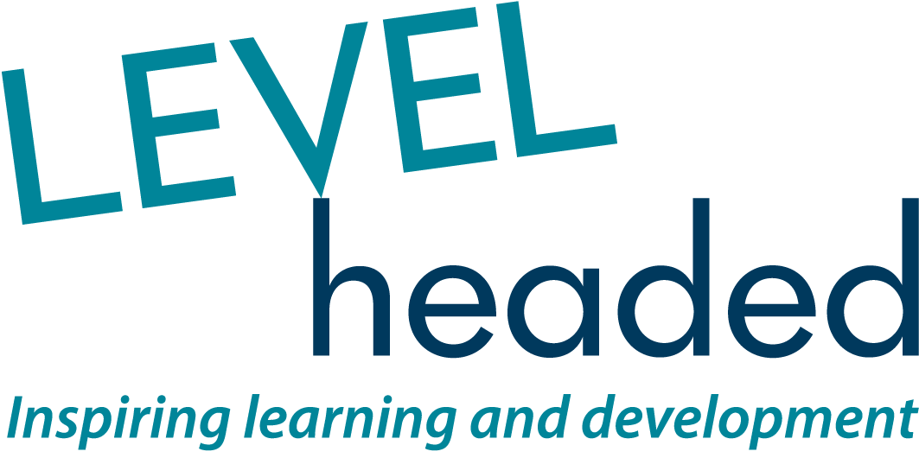

Strengthening the team

LEVELheaded is a small, tight knit and very successful organisation. Since 1992 (yes, 25 this year) we’ve been providing specialist Learning & Development interventions for non-profit, charitable and other social purpose organisations.

Our clients rate us very highly, as do the participants who attend our training. As a direct result we’re looking for another special person to join us; someone with an in depth knowledge of Leadership & Management theory, principles and practise, and the ability to share it with others.

You’d be joining an established team of long standing staff and professional role players who are committed to practising what we preach on L&D. No surprise then that, for the third time running (covering the last 10 years), we have been awarded Gold Standard for Investors in People. Maybe that explains our exceptional staff retention.

Or maybe it’s:
- The fun and joy of working with some of the best known and most dynamic organisations in the sector
- The satisfaction of being part of a highly supportive team
- Working on occasional international projects
- Our personalised benefits package
- Our commitment to our own personal development

To be transparent, it’s more than just a job on offer. We need someone who also wants to participate in the development of the business; someone who’s ready to be active in our strategy and organisational decision making as well as the day to day delivery of L&D interventions.

To download further information, please visit the website: www.levelheaded.org

Or, if you prefer, give us a call on 020 7538 9387 to find out more.

To apply please submit a letter of application that fully addresses job responsibilities and person specification, plus a detailed CV

Closing date: 5pm Thursday 2 November 2017
Shortlisted Applicants advised 6 November 2017
Interview dates: 13 November 2017 (Central London)

